**Big Data Programming**

**CSEE5590-0004/490-0004**

**Lab 2 Report**

Team : 6

Chandrasekhar Pentakota (class ID : 9)

Mustafa Bilal (class ID : 15)

**Links :**

<https://github.com/chanduhub/BigDataProgramming/wiki/Lab-2>

<https://youtu.be/7uVhoPZ0zWY>

https://github.com/bmian93/BigDataProgramming/tree/master/BigDataProgramming/Lab3

**HIVE USE CASE :**

**Creation of table**

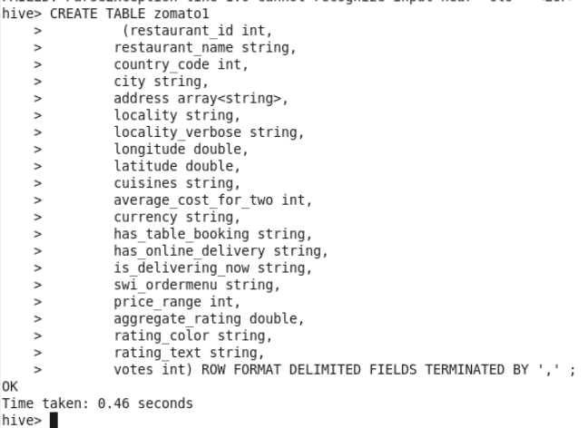

**Inserting data from csv file into table**

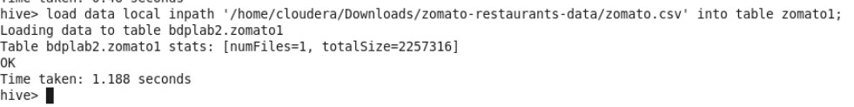

**Q1: Top 5 restaurants by looking at the number of votes**

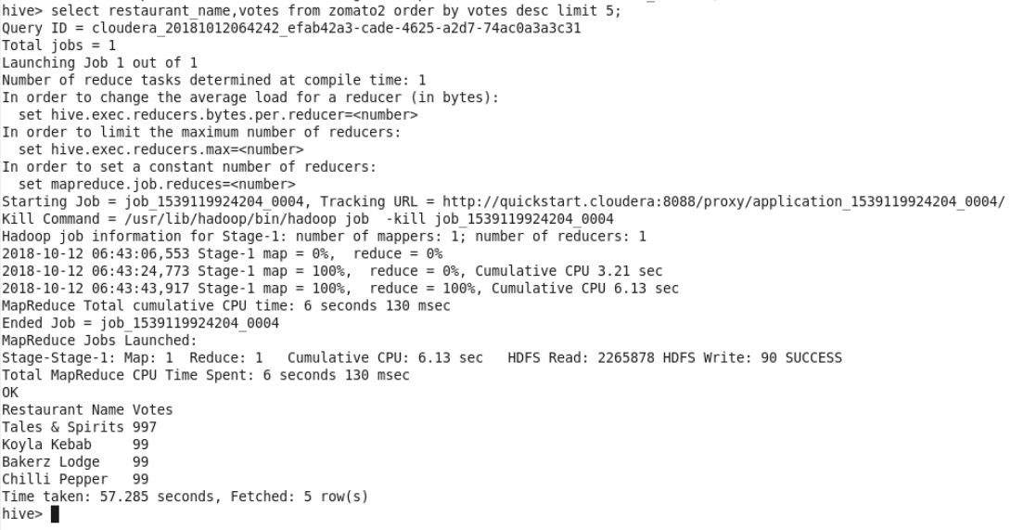

**Q2: Unique restaurants in the data set**

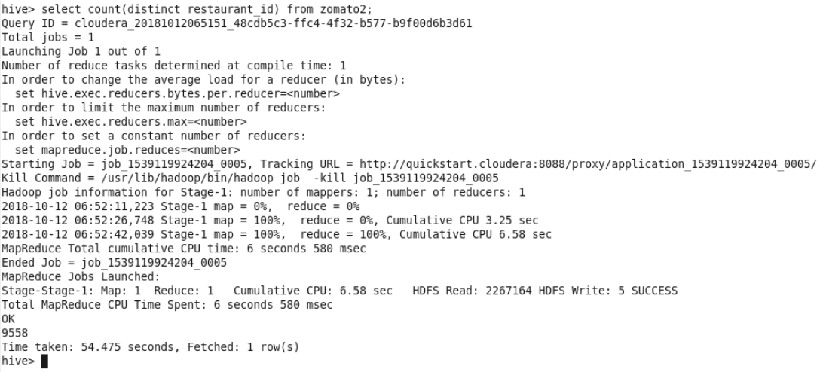

**Q3: Top 5 costliest restaurants**

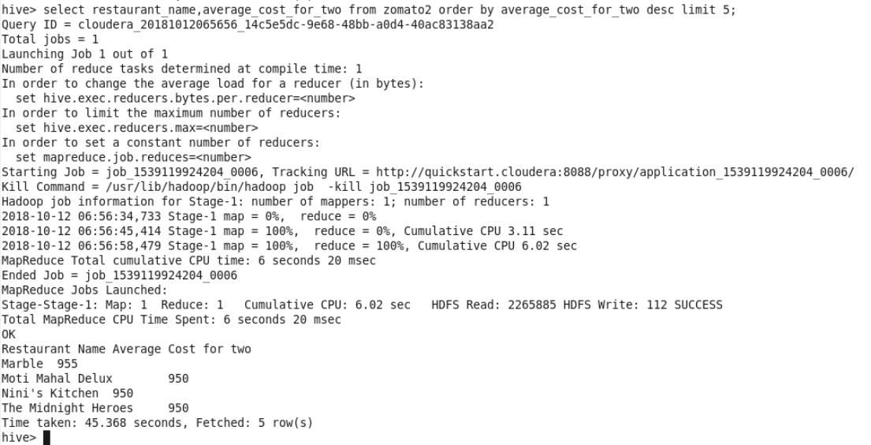

**Q4: Number of restaurants from each country**

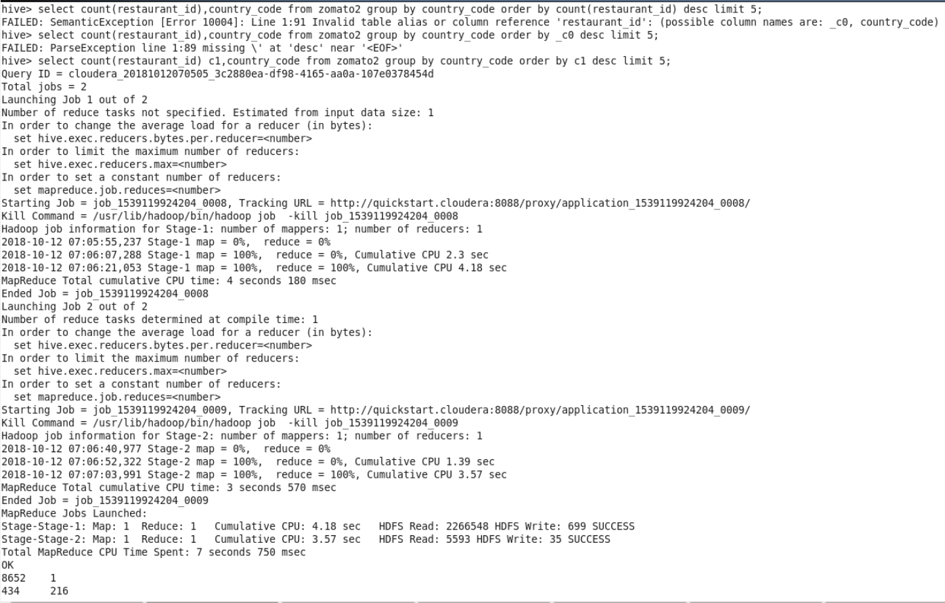

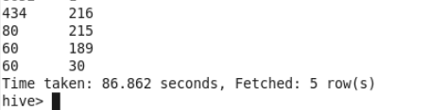

**Q5: number of restaurants in Zomato by city**

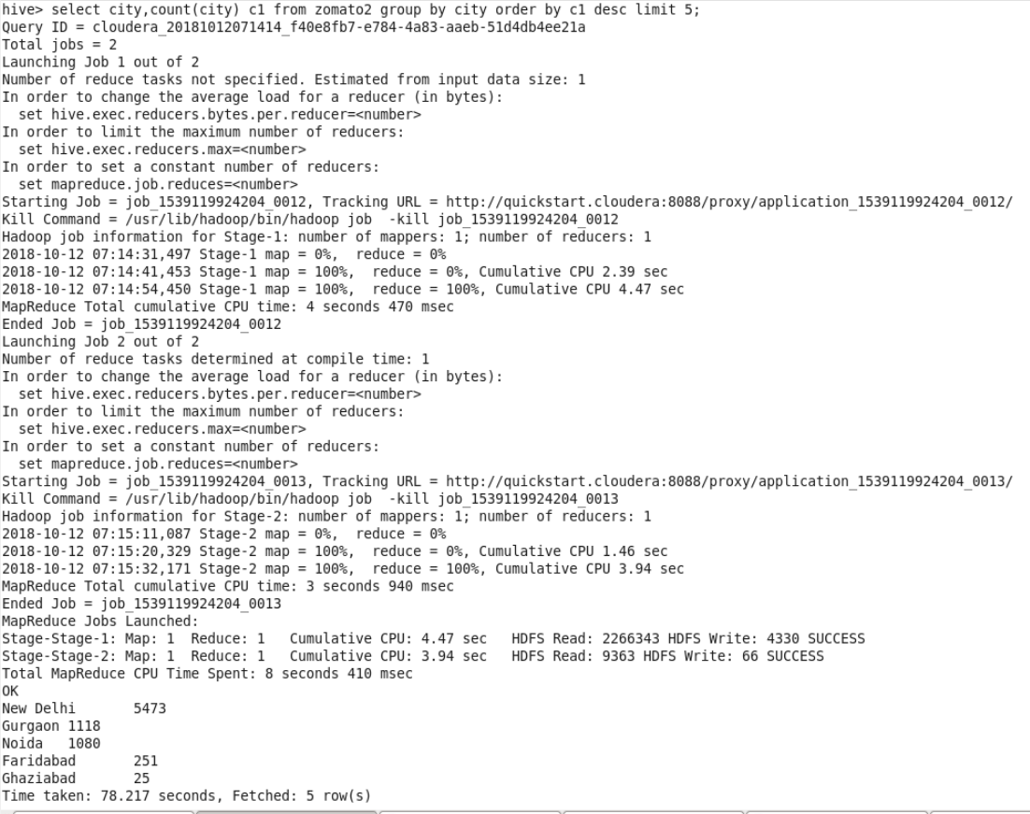

**Q6: Number of restaurants which has online delivery**

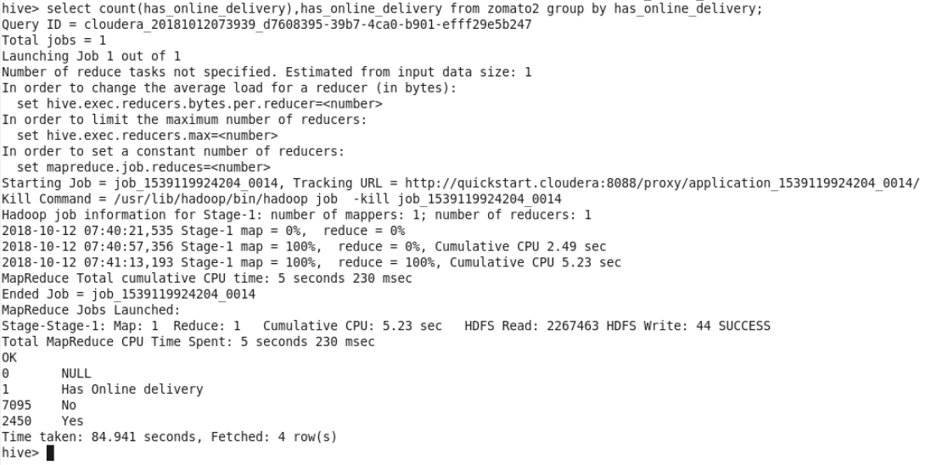

**Q7: Top 5 popular cuisines**

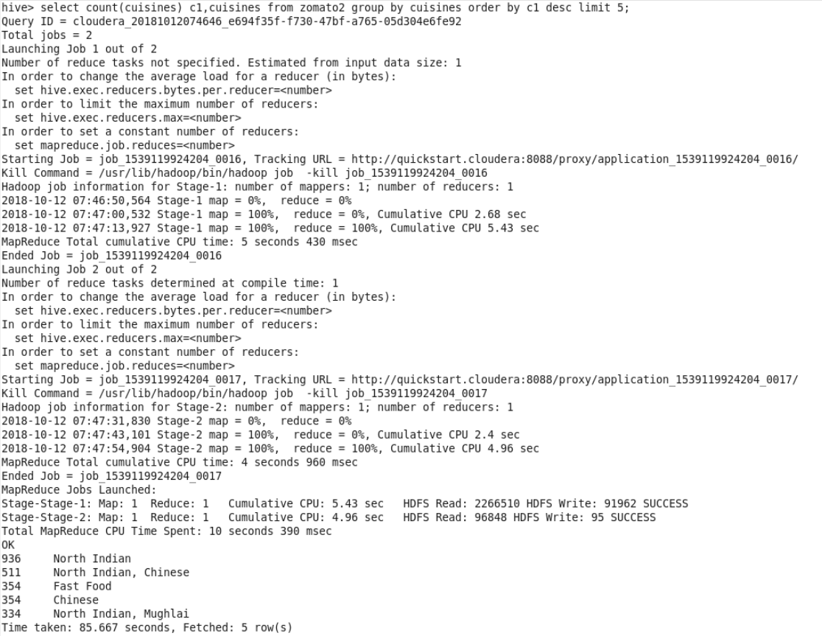

**Q8: average rating by count**

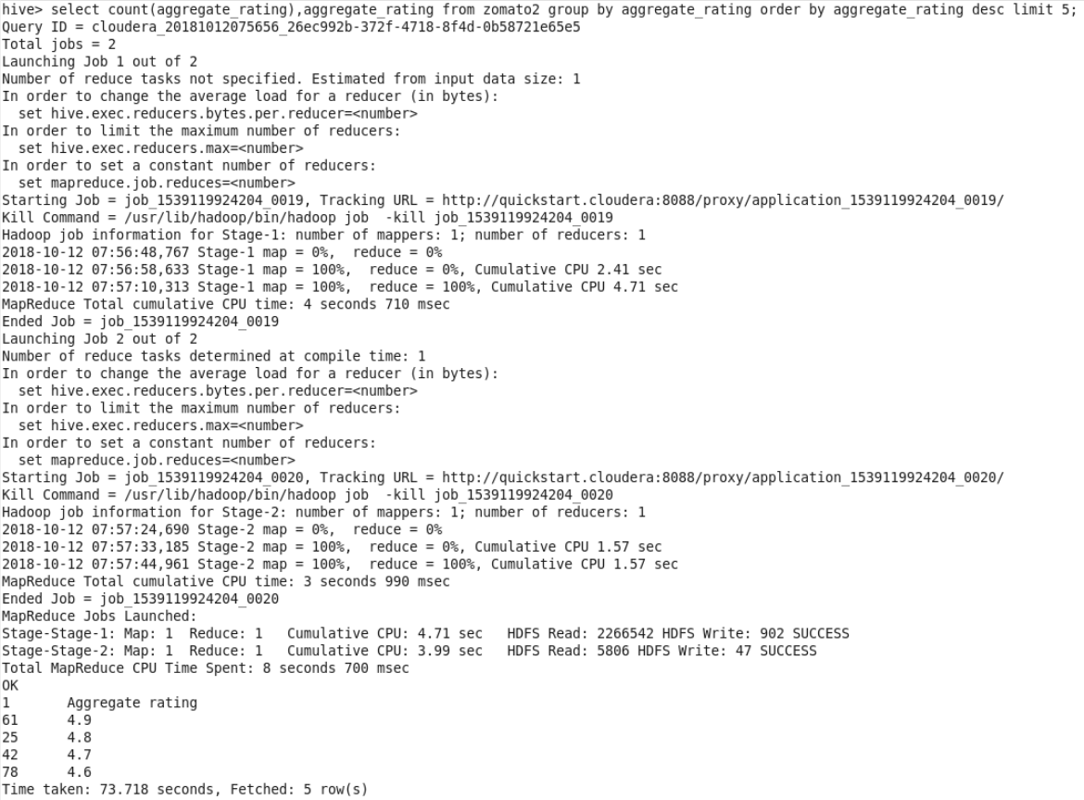

**Q9: Most used currencies in Zomato**

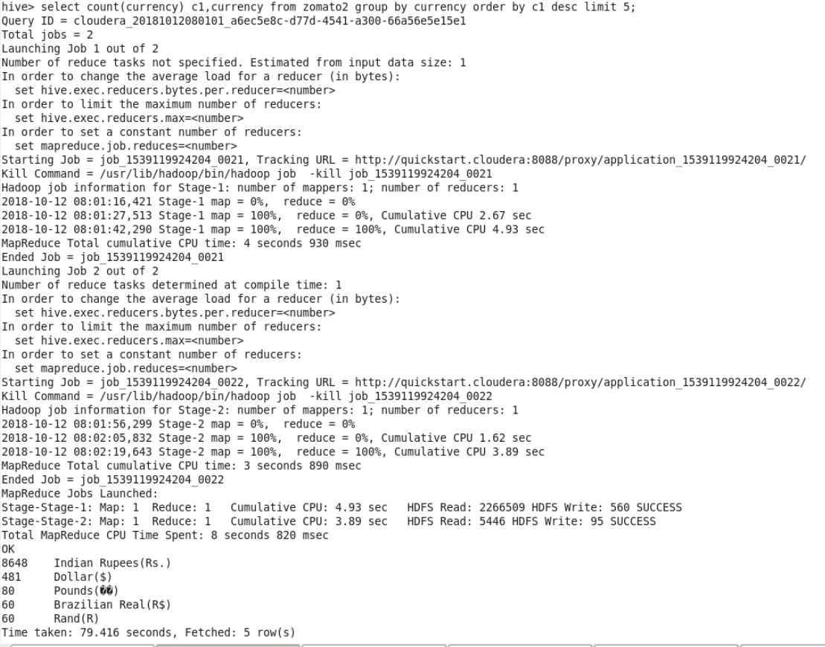

**Q10: Count of restaurants grouped by rating text**

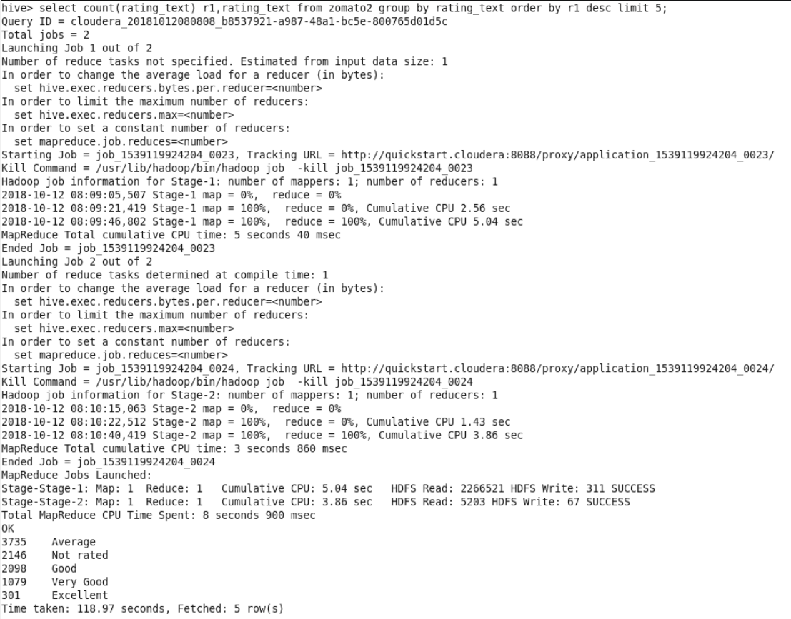

**CASSANDRA USE CASE:**

**Creation of keyspace and table**

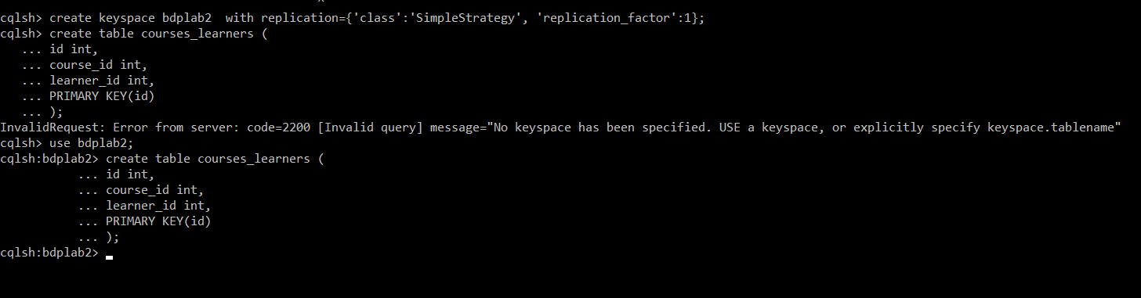

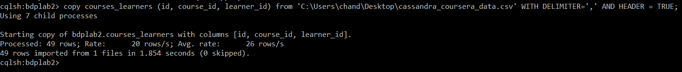

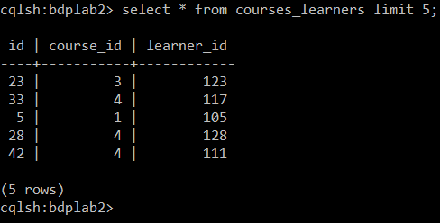

**Q1: Number of courses taken by the user 101**

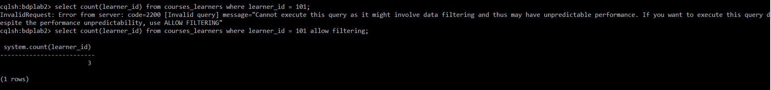

**Q2: Users who are enrolled for the course number 1**

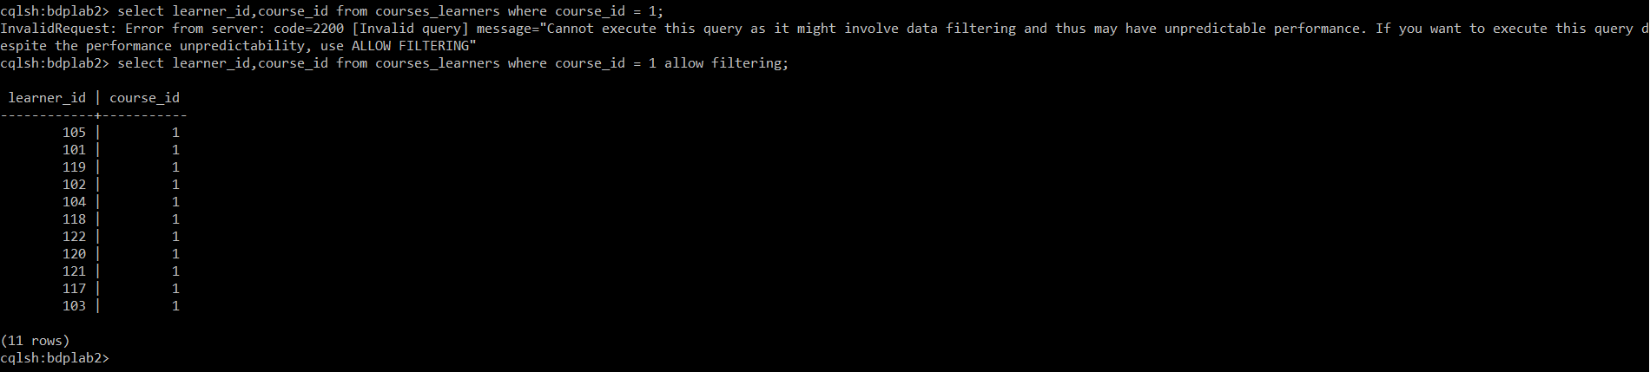

**Q3: Total number of users who are enrolled for the course 4**

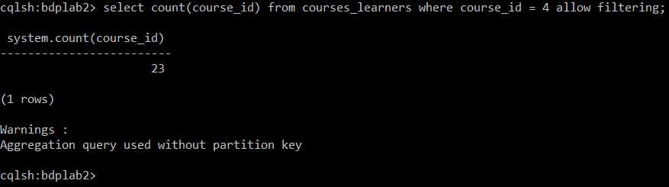

**SOLR USE CASE :**

**Creation of schema and importing data**

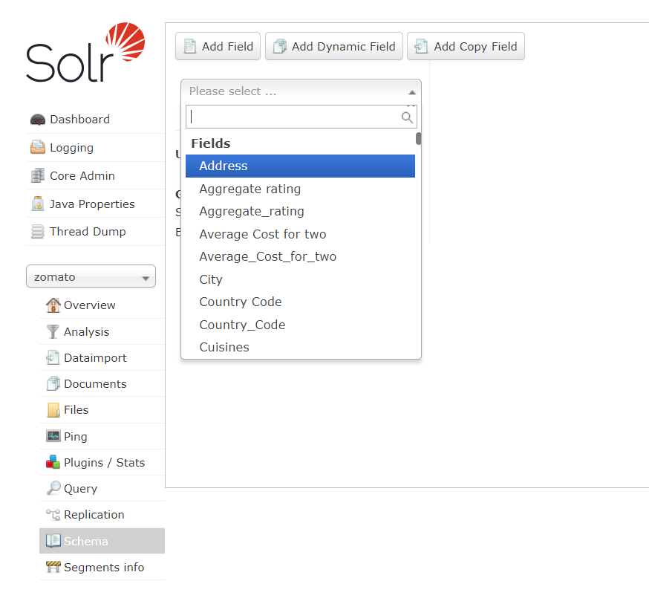

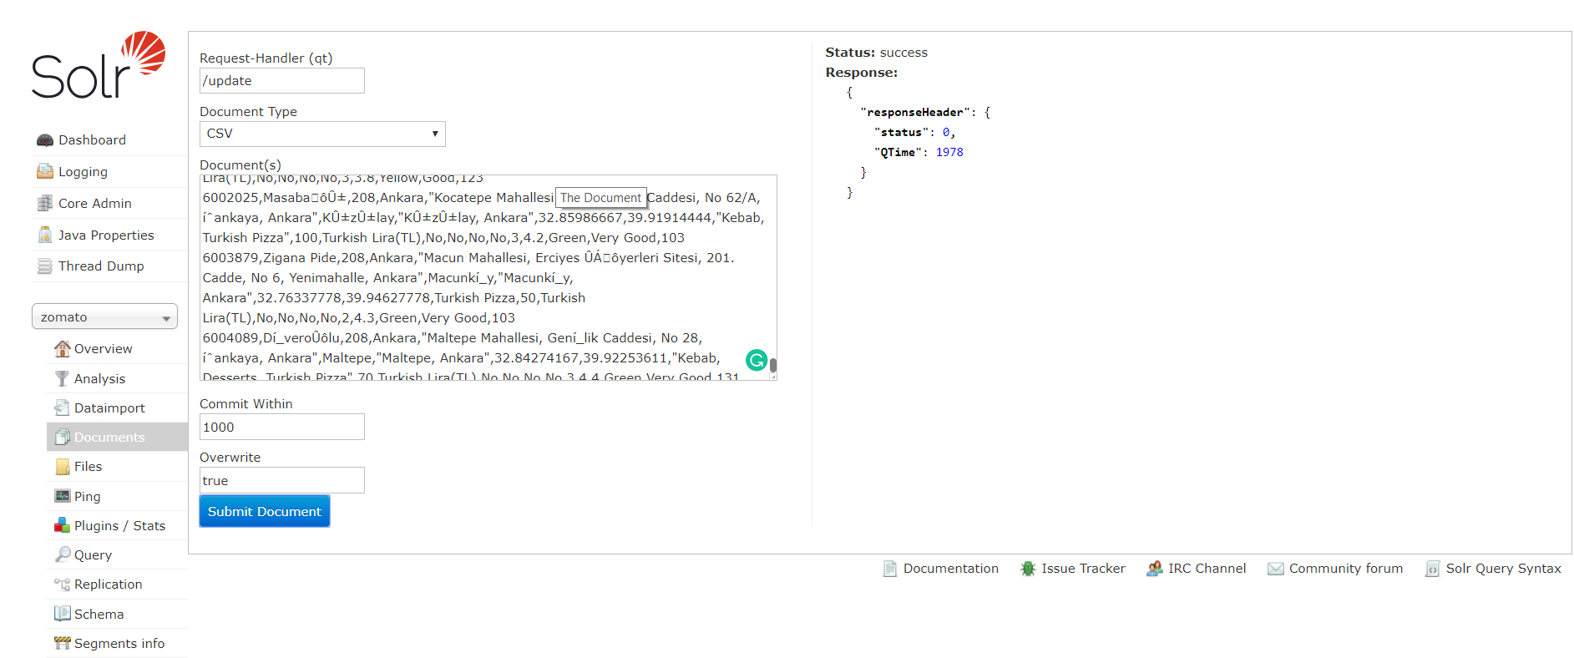

**Q1: Restaurants who does not provide online delivery**

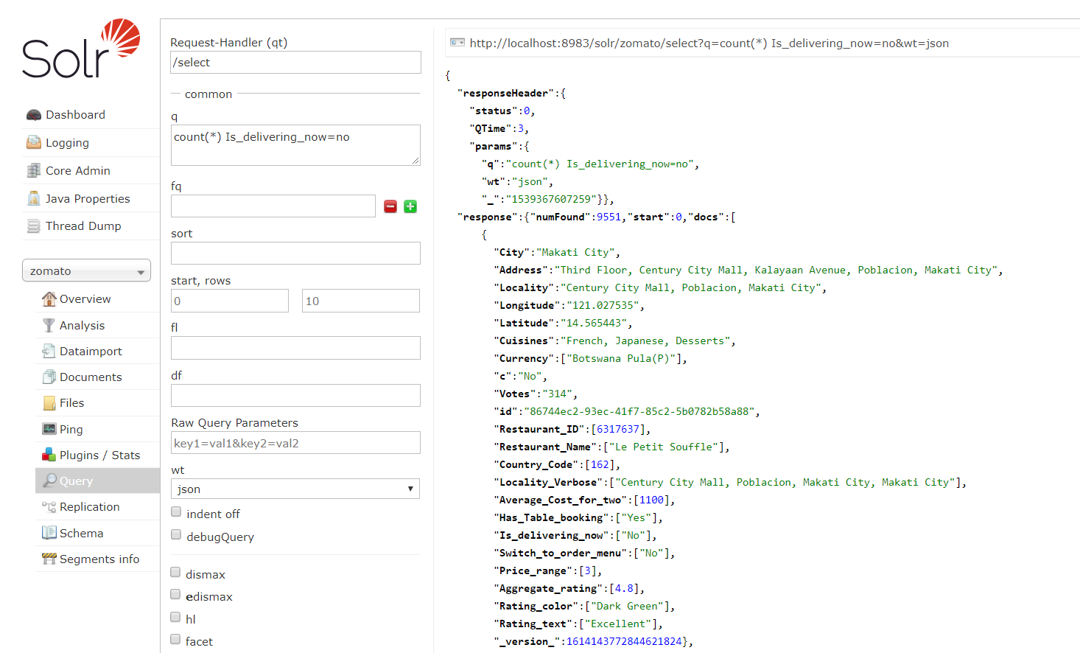

**Time Elapsed = 3msec**

**Q2: Restaurant which has both tables booking and online delivery**

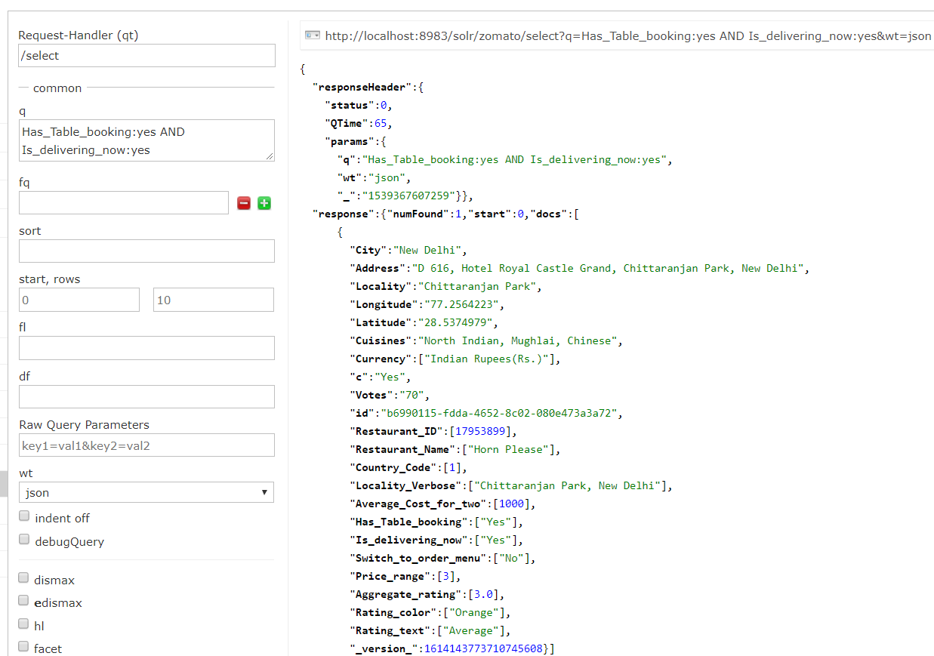

**Time Elapsed = 65msec**

**Q3: Restaurants with Average ratings**

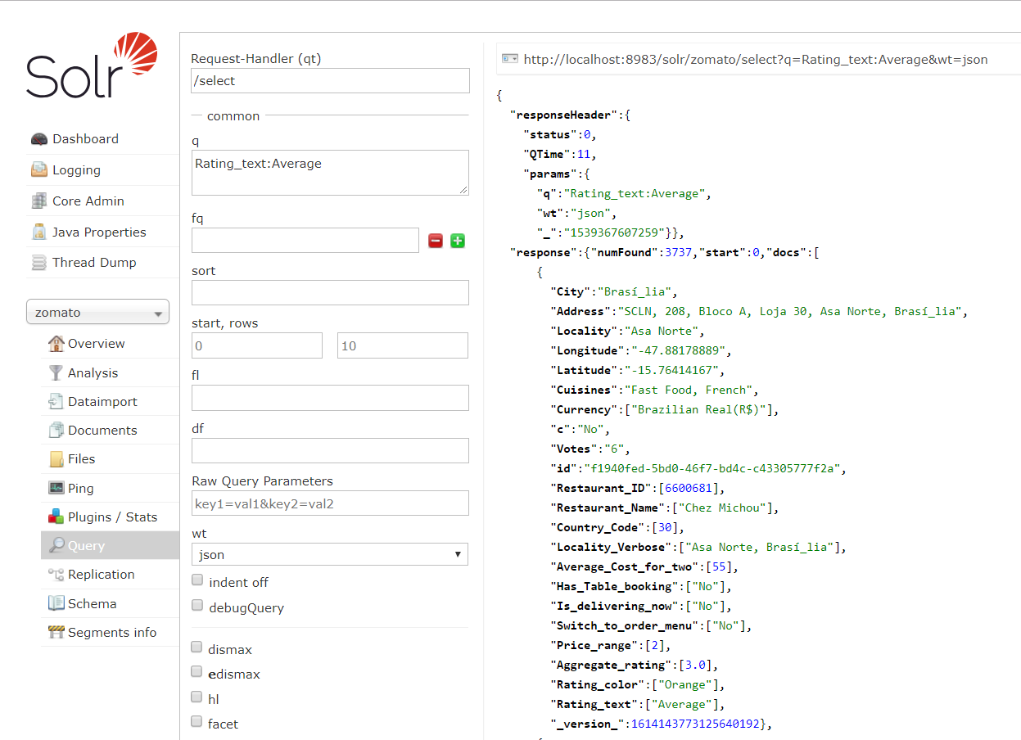

**Time Elapsed = 11msec**

**Q4: Aggregate rating 4 restaurants**

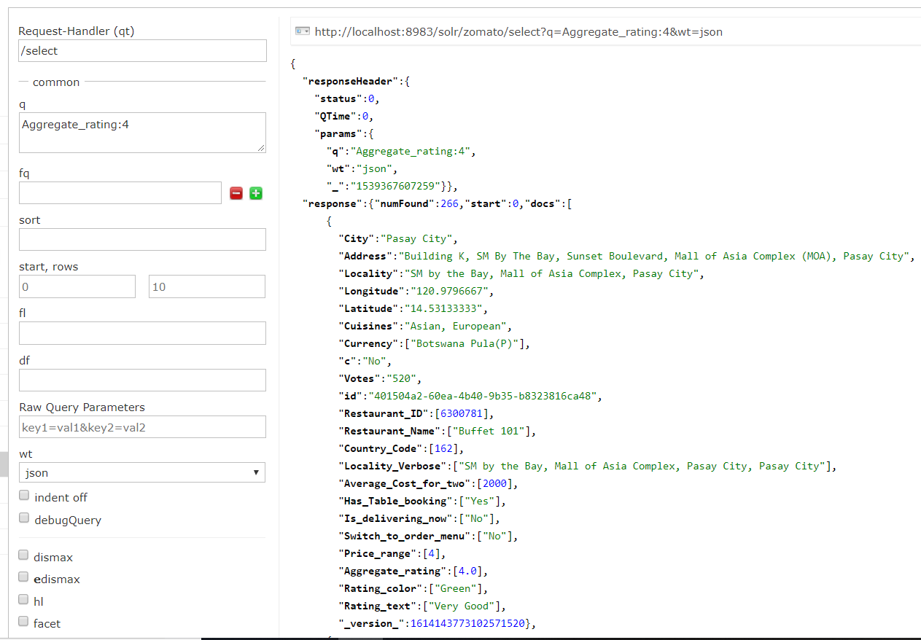

**Q5: Restaurants with excellent food rating and top rated, sorted by rating**

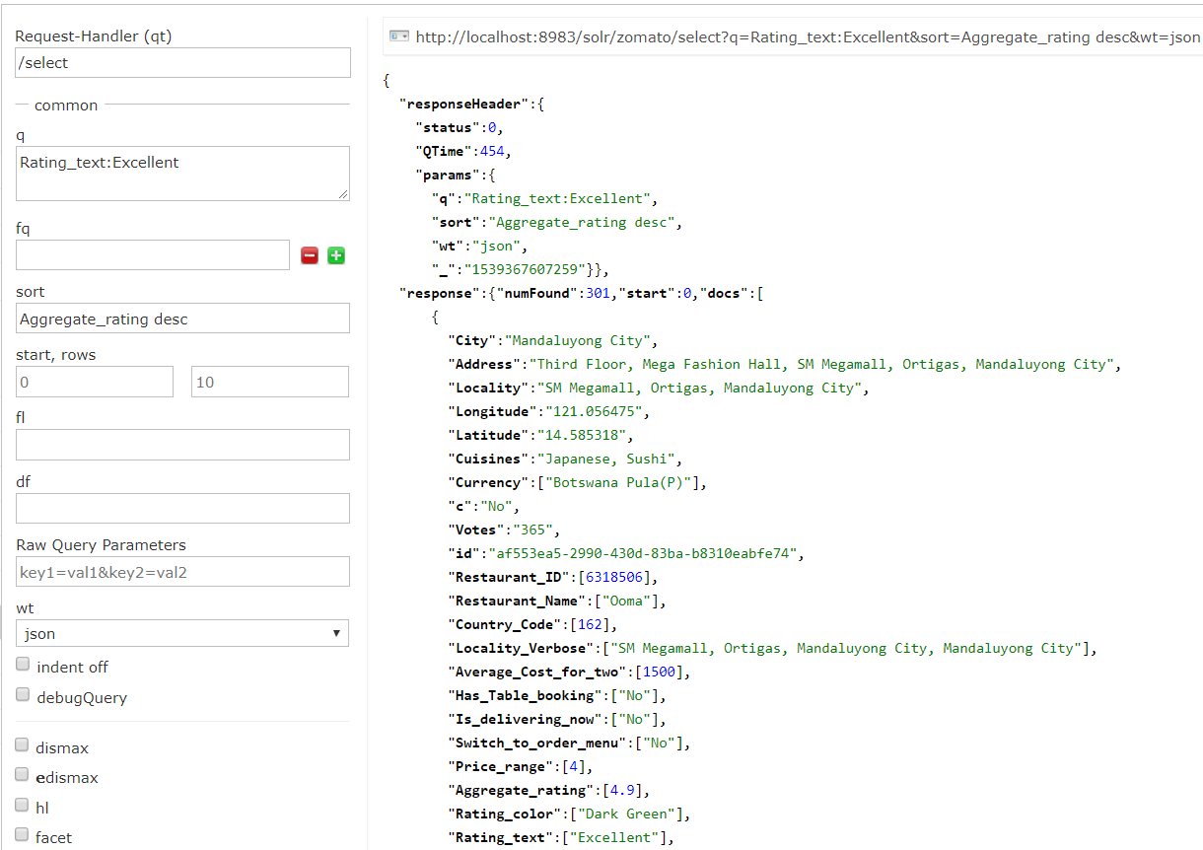

**Time Elapsed = 454msec**

**Q6: Top 10 costliest restaurants**

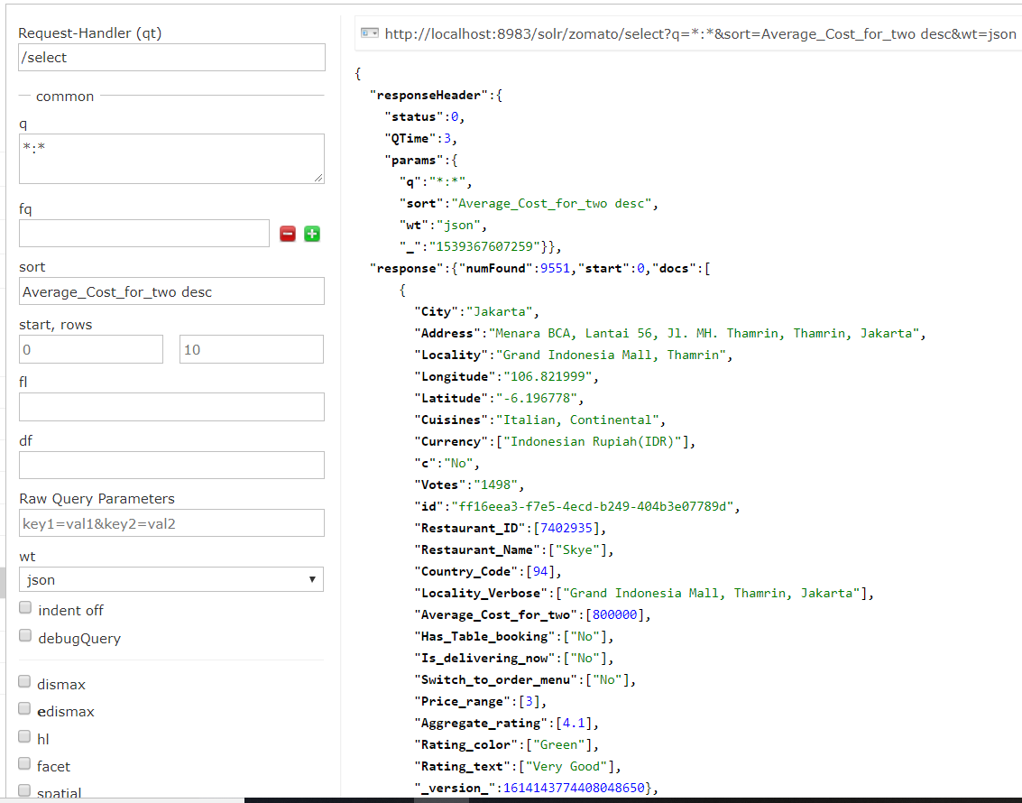

**Q7: Count the number of restaurants from India**

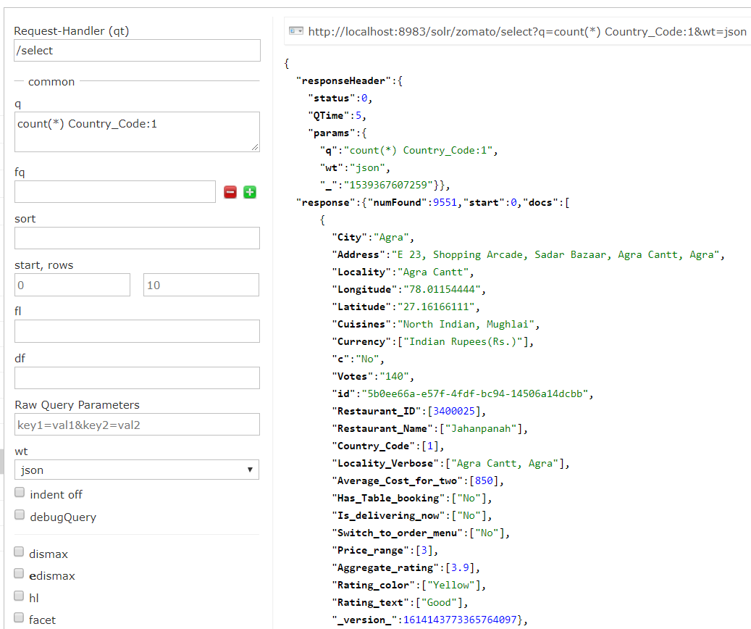

**Time Elapsed = 5msec**

**Q8: Restaurants which serve North Indian Food**

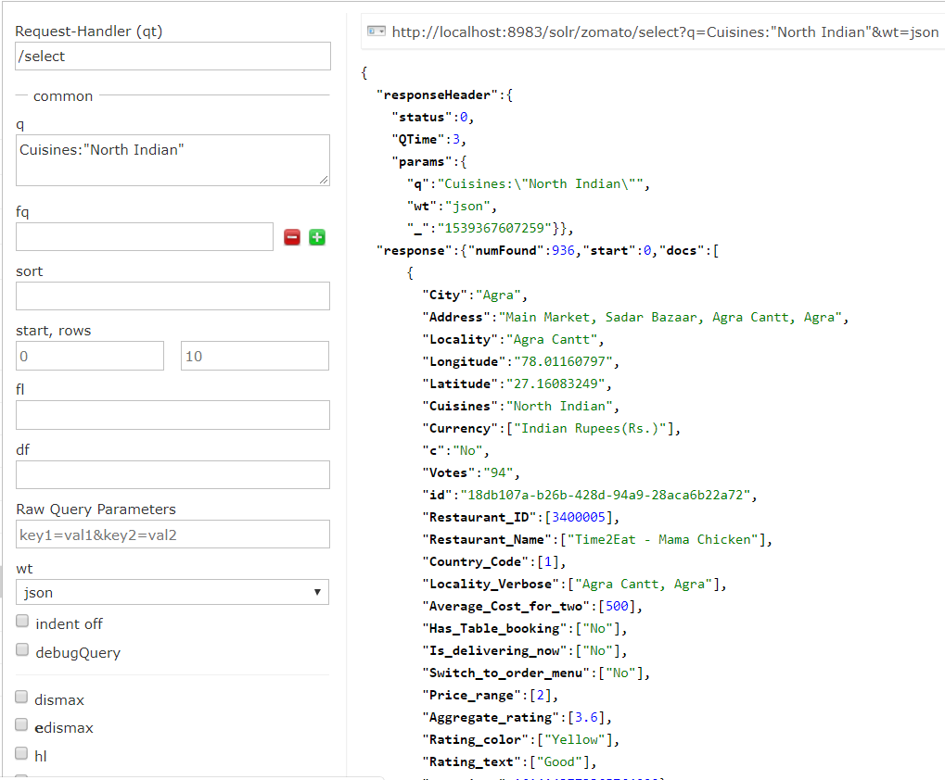

**Time Elapsed = 3msec**

**Q9: Count number of restaurants from Agra and serve North Indian food**

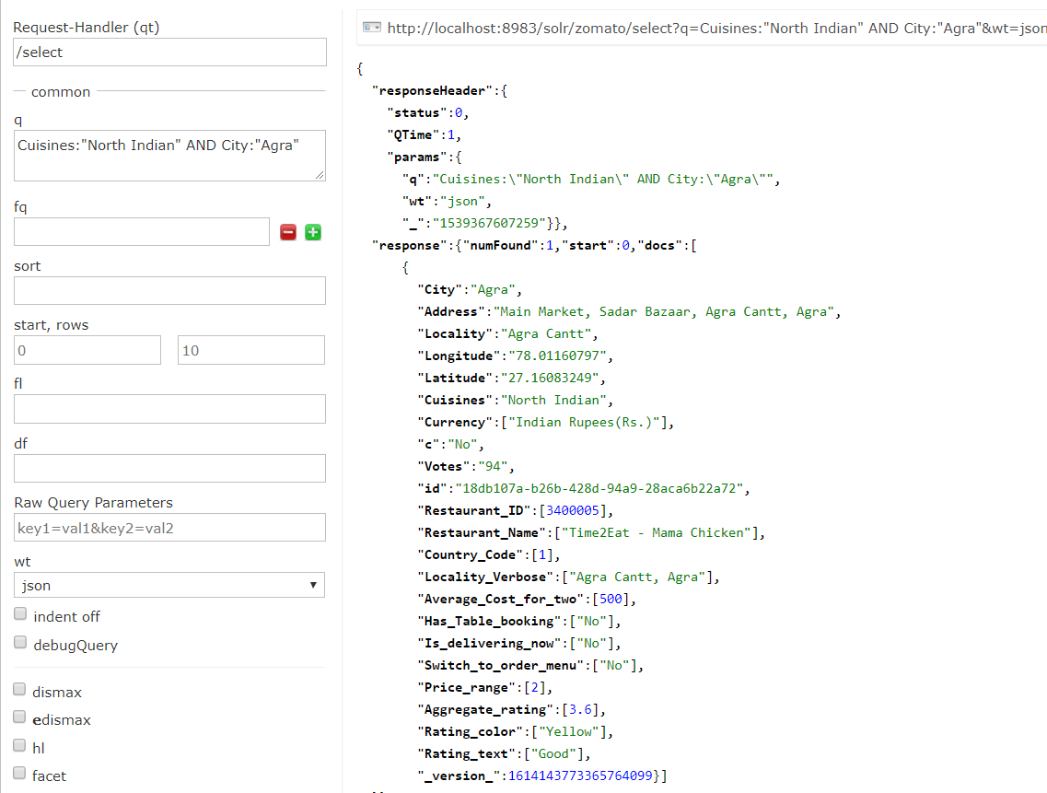

**Time Elapsed = 1msec**

**Q10: Sorted restaurants in the order of votes, which has more popularity**

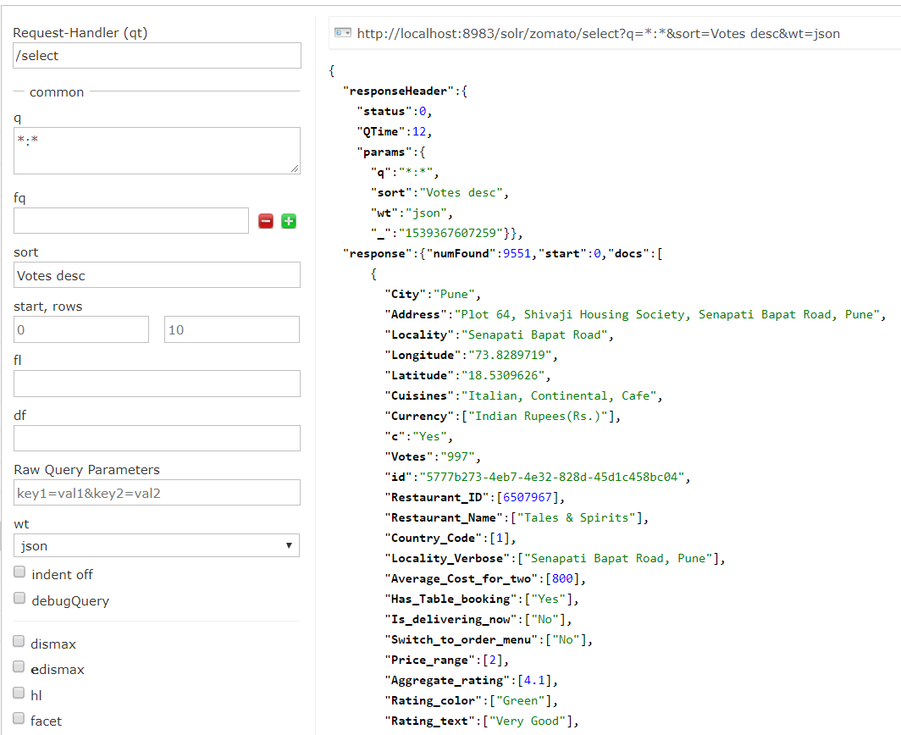

**Time Elapsed = 12msec**